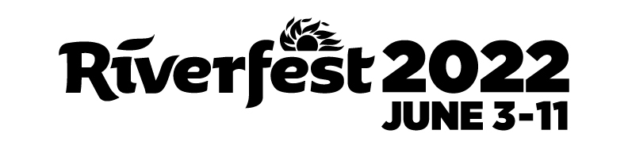
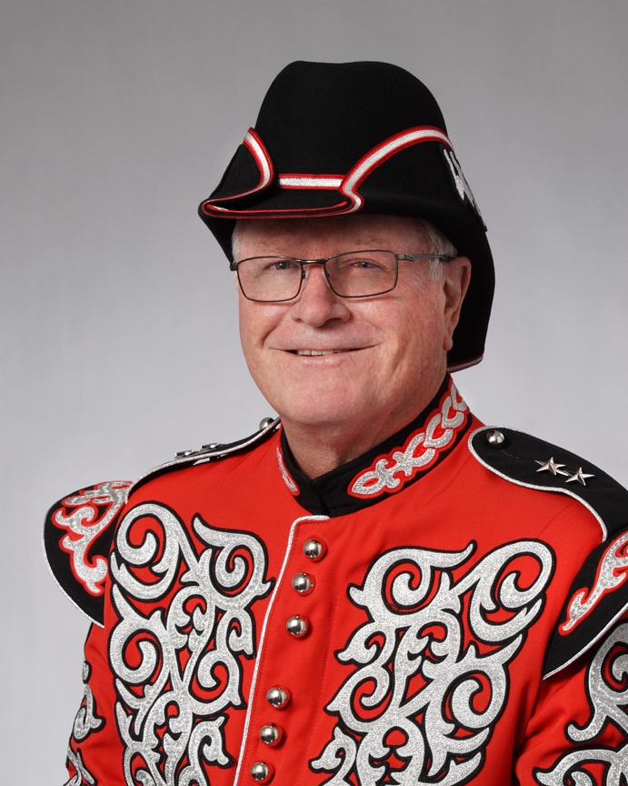
Admiral Windwagon Smith XLVIII
Barry Schwan
Admiral Windwagon Smith XLVIII Schwan is the president and owner of House of Schwan, Inc., a local Anheuser-Busch, craft beer, non-alcoholic beverage, and spirits wholesaler, which was founded in 1960 by his father Barney. This is the 50th consecutive year House of Schwan has been a major sponsor of Riverfest.
“Community Involvement has always been a pillar of House of Schwan’s commitment to this community. We are proud to have been a sponsor throughout the 50 years of the festivals history. And I am extremely honored to have been chosen to represent the Wichita Riverfestival in its 50th year.”
An active member of Wichita’s business and philanthropy communities for decades, Schwan currently serves on the boards of directors of the Wichita State University Foundation and the Sedgwick County Zoological Society. Many area organizations have benefitted from his leadership as board chair, including the Wichita Regional Chamber of Commerce, Kansas Humane Society, Greater Wichita Area Sports Commission, the Wichita Children’s Home, WSU Foundation, Kansas Beer Wholesalers Association, and the Sedgwick County Zoological Society. He holds a Bachelor of Science degree from the University of Colorado.
The admiral and his wife, Cindy, have been married for 42 years and have two children, Devon, and Mallory, and one grandchild, Lyric. In his spare time, he enjoys spending time with family and friends, exercising, and travel.
The tradition of Admiral Windwagon Smith was established in 1974, when John Bell first wore the red coat during the third Riverfest, then known as Wichitennial River Festival. Schwan is the 48th admiral.

